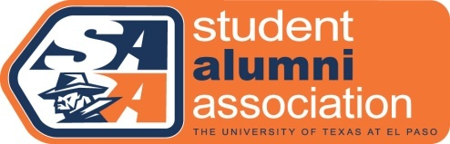

Spend Thanksgiving with a Miner Family

Thanksgiving is right around the corner and the UTEP Student Alumni Association is sponsoring an “Adopt-A-Miner” program for students who aren’t able to go home for the holidays or perhaps are new to the Thanksgiving custom. The UTEP Student Alumni Association, the UTEP Alumni Association, the UTEP El Paso Alumni Chapter and the UTEP Parents Association have teamed up to provide Miner’s with a home-cooked meal with UTEP families on Thanksgiving.

If you are a student who would like to be “adopted” for a Thanksgiving dinner with a Miner Family, simply fill out the form below and return it to our office before November 19th, 2012. Once we have consolidated all the information, we will contact you with the information you will need to celebrate Thanksgiving with a Miner family. If you DO NOT receive a confirmation, there is no guarantee there will be a family available. For questions or additional information, please e-mail jreed2@utep.edu or call 915-747-5592.

Some Guidelines
1. You will receive directions to the meeting location.
2. Please wear appropriate clothing – casual, but nice. No torn jeans or inappropriate slogans on t-shirts.
3. Students will be asked to sign a liability waiver form.
4. Families have been asked to “adopt” two students so you are welcome to partner with a friend – just let us know.
5. You will be matched with a family based on the information provided below. (Language preference, transportation needs, etc.)

Please fill out the requested information

Information of Student
Year in School:
Major:
First Name:
Last Name:
Language Preference:
Street Address:
City, State, Zip:
Will you need a ride?:
Home telephone:
Cell phone:
E-mail Address (required):
Any special requirements or requests that we should know about? (Dietary restrictions, allergies?)

(915) 747-8600 Margaret and Peter de Wetter Center alumni.utep.edu/saa

